# Overview

Once a zone and its associated file are created you are ready to configure resource records. The domain name or zone identifies where the records for your organization are located and allow users on the Internet or your internal network to find them. The resource records contain the information that users need to access resources. In this guided practice, you will add the most common types of resource records to the zones that you previously created.

# Objectives

* + Configure DNS on Windows server

## Skills Reviewed

* None

## New Skills

* Creating common DNS resources records using the GUI and PowerShell
* View DNS resource records using the GUI and PowerShell

## References

# Initial Conditions

* Guided Practice – Creating DNS Zones in Windows is complete

# Final Conditions

* **KMW.net** and **KMW.org** primary forward lookup zones contain the following resource records:
  + Address records for **Host01**, **Host02**, **Host3**, and **Host04**.
  + **CNAME** records for **www** and **ftp** servers.
  + **MX** record.
* Primary reverse lookup zones for the **10.1.1.0/24** network and **10.1.2.0/24** networks, contain the following resources records:
  + Pointer records created for **Host01**, **Host02**, **Host3**, and **Host04**.

# Instructions

## Adding Resource Records

The information in a zone file is contained in the resource records in that file. The most common record in a forward lookup zone is the Address (A) or Host record. The most common record in a reverse lookup zone is a Pointer (PTR) record.

### Adding an Address (A) or Host Record

For DNS clients to resolve host names to IP addresses you need to add A records to your zone. **Note**: *The records created in these zones are for hosts that do not exist in your virtual network*.

To add an **A record** to the **kmw**.**net** zone for the host **Host01** with an IP address of **10.1.1.201** using the GUI, perform the following:

1. Logon to the **Server-01** virtual machine with the **administrator** account.
2. Open the **DNS** **Manager** console
3. Highlight the **kmw.net** folder in the **Forward** **Lookup** **Zones** node in the console tree.
4. Select **New Host (A or AAAA) …** from the **context** **menu** for the **kmw**.**net** node.
5. In the **Name** edit box of the **New** **Host** dialog box type **Host01.**
6. In the **IP address:** edit box of the **New** **Host** dialog box type **10.1.1.201** and click the **Add Host** button.
7. Repeat the step above for the following hosts:
   1. **Host02 - 10.1.1.202.**

To add an **A record** to the **kmw**.**org** zone for the host **Host03** with an IP address of **10.1.2.101** using the command line, perform the following:

1. Open a **PowerShell** console with administrative rights
2. Type the following in the shell:

Add-DnsServerResourceRecord -ZoneName kmw.org -A -Name Host03 -IPv4Address 10.1.2.101 -Verbose

1. You should see the output shown in the **Figure** below:

Notice the **-Verbose** option is used in so that you have some feedback from the command.



1. Repeat the step above for the following host:
   1. **Host04 - 10.1.2.102**
2. Verify the records were created by typing the following command:

Get-DnsServerResourceRecord -ZoneName kmw.org

1. Your output should look like the figure below.

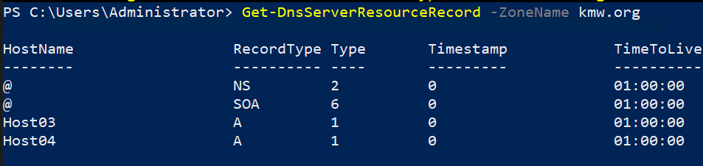

### Adding a PTR Record

Pointer (PTR) records are used to perform reverse lookups. These are often helpful when analyzing logs so that you can identify computer names instead of IP addresses.

To add a **PTR record** to the **1.1.10.in-addr.arpa** zone for the host **Host01** with an IP address of **10.1.1.201** using the GUI, perform the following:

1. Logon to the **Server-01** virtual machine using the **administrator** account.
2. Open the **DNS** **Manager** console.
3. Highlight the **1.1.10.in-addr.arpa** folder in the **Reverse** **Lookup** **Zones** node in the console tree.
4. Select **New Pointer (PTR)…** from the **context** **menu** for the **1.1.10.in-addr.arpa** node.
5. In the **Host IP Address:** edit box of the **New** **Resource Record** dialog box type **10.1.1.201.**
6. In the **Host Name** edit box of the **New** **Resource Record** dialog box type **Host01.kmw.net.** and click the **OK** button.
7. Repeat the step above for the following hosts:
   1. **Host02.kmw.net. - 10.1.1.202**

To add a Pointer **PTR record** to the **2.1.10.in-addr.arpa** zone for the host **Host01.kmw.org** with an IP address of **10.1.2.101** using the command line, perform the following:

1. Logon to the **Server-01** virtual machine using the **administrator** account.
2. Open a **PowerShell** console with administrative rights
3. Type the following in the shell:

Add-DnsServerResourceRecord -ZoneName 2.1.10.in-addr.arpa -PTR -Name 101 -PtrDomainName Host03.kmw.org -Verbose

1. You should see the output shown in the figure below.



1. Repeat the step above for the following hosts:
   1. **Host04.kmw.org. - 10.1.2.102**

### Adding a CNAME Record

CNAME or Alias records are used to provide a host with more than one host name. This is often done to help users locate the servers running common services like mail, ftp, www, and others.

To add a **CNAME record** to the **kmw**.**net** zone to allow for the host **Host01.kmw.net** to be known as **www** using the GUI, perform the following:

1. Logon to the **Server-01** virtual machine using the **administrator** account.
2. Open the **DNS** **Management** console.
3. Highlight the **kmw.net** folder in the **Forward** **Lookup** **Zones** node in the console tree.
4. Select **New Alias (CNAME)…** from the **context** **menu** for the **kmw**.**net** node.
5. In the **Alias Name** edit box of the **New** **Resource Record** dialog box type **www.**
6. In the **Fully qualified domain name (FQDN) for target host:** edit box of the **New Resource Record** dialog box type **Host01.kmw.net.** and click the **OK** button.
7. **Repeat** the **step** above **for** the **following** **host**:
   1. **Host02.kmw.net. - ftp**

To add a **CNAME record** to the **kmw**.**org** zone to allow for the host **Host01.kmw.org** to be known as **www** using PowerShell, perform the following:

1. Logon to the **Server-01** virtual machine using the administrator account.
2. Open a **PowerShell** console with administrative rights.
3. Type the following in the shell:

Add-DnsServerResourceRecord -ZoneName kmw.org -CName www -HostNameAlias Host03.kmw.org -verbose

1. You should see the output shown in the Figure below:



1. Repeat the step above for the following hosts:
   1. **Host04.kmw.org. - ftp**
2. Verify the records were created by typing the following command:

Get-DnsServerResourceRecord -ZoneName kmw.org

### Adding an MX Record

An MX record is used by other organizations to locate your mail server to deliver mail to your domain.

To add an **MX record** to the **kmw**.**net** zone to identify the host **Host02.kmw.net** as a mail server for our domain using the GUI, perform the following:

1. Logon to the **Server-01** virtual machine using the administrator account.
2. Open the **DNS** **Manager** console.
3. Highlight the **kmw.net** folder in the **Forward** **Lookup** **Zones** node in the console tree.
4. Select **New Mail Exchanger (MX)…** from the **context** **menu** for the **kmw**.**net** node.
5. In the **Host or child domain:** edit box of the **New** **Resource Record** dialog box leave it blank**.**
6. In the **Fully qualified domain name (FQDN) of mail server:** edit box of the **New Resource Record** dialog box type **Host02.kmw.net.** and **click** the **OK** button.

To add an **MX record** to the **kmw**.**org** zone to identify the host **Host04.kmw.org** as a mail server for our domain using PowerShell, perform the following:

1. Logon to the **SERVER-01** virtual machine using the administrator account
2. Open a **PowerShell** console with administrative rights
3. Type the following in the shell:

Add-DnsServerResourceRecord -ZoneName kmw.org -MX -Name kmw.org. -MailExchange Host04.kmw.org. -Preference 10

1. Verify the MX record was created using one of the methods shown previously.

## Submission Requirements

1. **Download** the **grading** **script** from the assignment page to the **C:\Scripts** folder.
2. Check your lab by running the following command:

Invoke-Pester -Path C:\Scripts\GP10-Creating_DNS_Resource_ Records.test.ps1

**Note**: You will see a security warning when running the script. Enter **R** to run the script.

If you want to see more detail, add **-Output Detailed** to the command. This may assist you with troubleshooting

Invoke-Pester -Path C:\Scripts\GP10-Creating_DNS_Resource_ Records.test.ps1 -Output Detailed

1. You should not see any red in the output. Red in the PowerShell way of telling you that an error condition exists. Most of the time, the output will tell you what is wrong. If it is not obvious, contact your teacher and ask for assistance. You will be learning PowerShell during this term. **Correct** any **errors** you may have and run the script until all the output has no red. You should see the output like the images below.

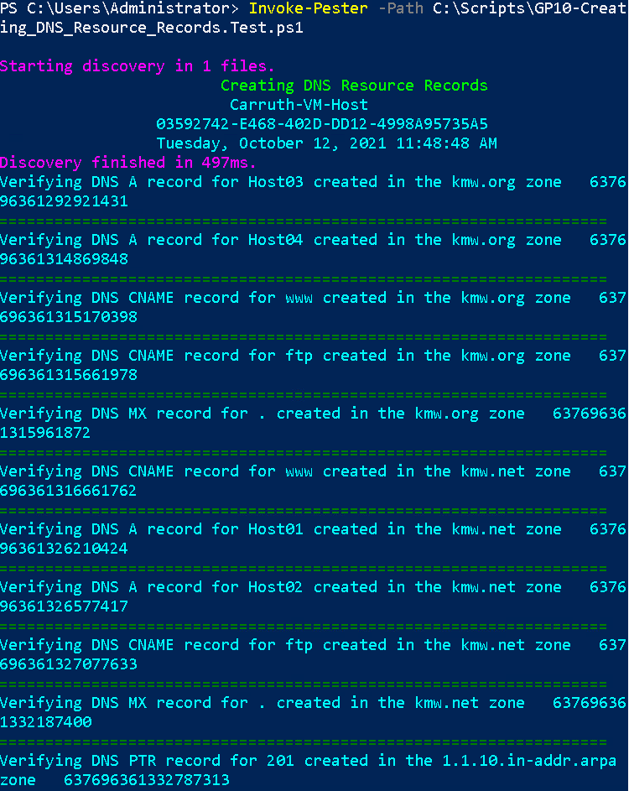

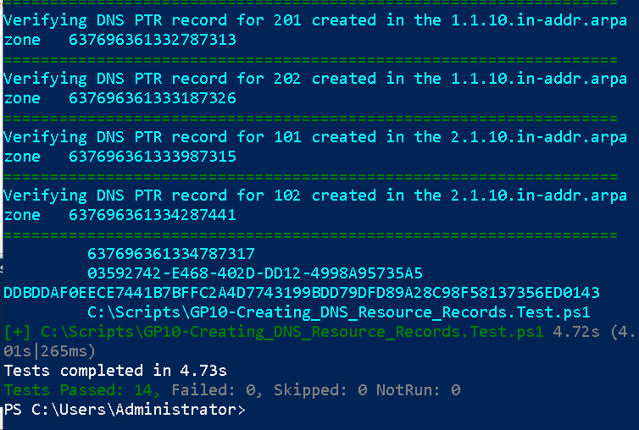

1. Capture a snippet that shows the PowerShell Command and all its output. If you must use more than one snippet to capture the output, you must have at least **one line of overlap** in the snippets. The text in the snippets **must be legible** when pasted into the Word document. Paste the snippet(s) into a **new** **Word** **document**
2. **Fill** **in** the **information** in the following table. Copy the following table into the **Word** **document** and fill in the information about all the **new** commands used in this lab (the example provided is not a new command and should be deleted):

|  |  |  |
| --- | --- | --- |
| PowerShell Commands | | |
| Command | Example | Description |
| Get-Childitem | Get-Childitem -Path C:\ | Displays the files in the C:\ directory |
|  |  |  |
|  |  |  |
|  |  |  |
|  |  |  |
|  |  |  |

1. **Upload** the **document** in the submission area of the assignment.